**MESS WEBSITE**

**DONE BY**

**1.VIDUSHI VANI**

**2.SHISHAGRA**

**Log In page details**

FUNCTIONS WHICH ARE BASICALLY USED WHILE CREATING THE LOGIN &

SIGN-UP PAGE *WIREFRAME:*

1. Used the meta tag for making the size of the website
2. Font taken using the cross origin
3. Used the header tags for give the title like sign in and sign up and login
4. Used anchor tag with href to connect the login and sign up with various social media platforms
5. Used class tags for panel making to bring the responsiveness.
6. Connected the css and js file using the src command

*CSS:*

1. .header file
2. Nav file
3. Hero btn
4. Hero btn hover
5. .layer
6. .testimonals

|  |  |
| --- | --- |
| 7. | @import |
|  | url("https://fonts.googleapis.com/css2?family=Poppins:wght@200;300;400;500;600; |
|  | 700;800&display=swap"); |

1. .panel
2. .transperent
3. Button enabling and disabling

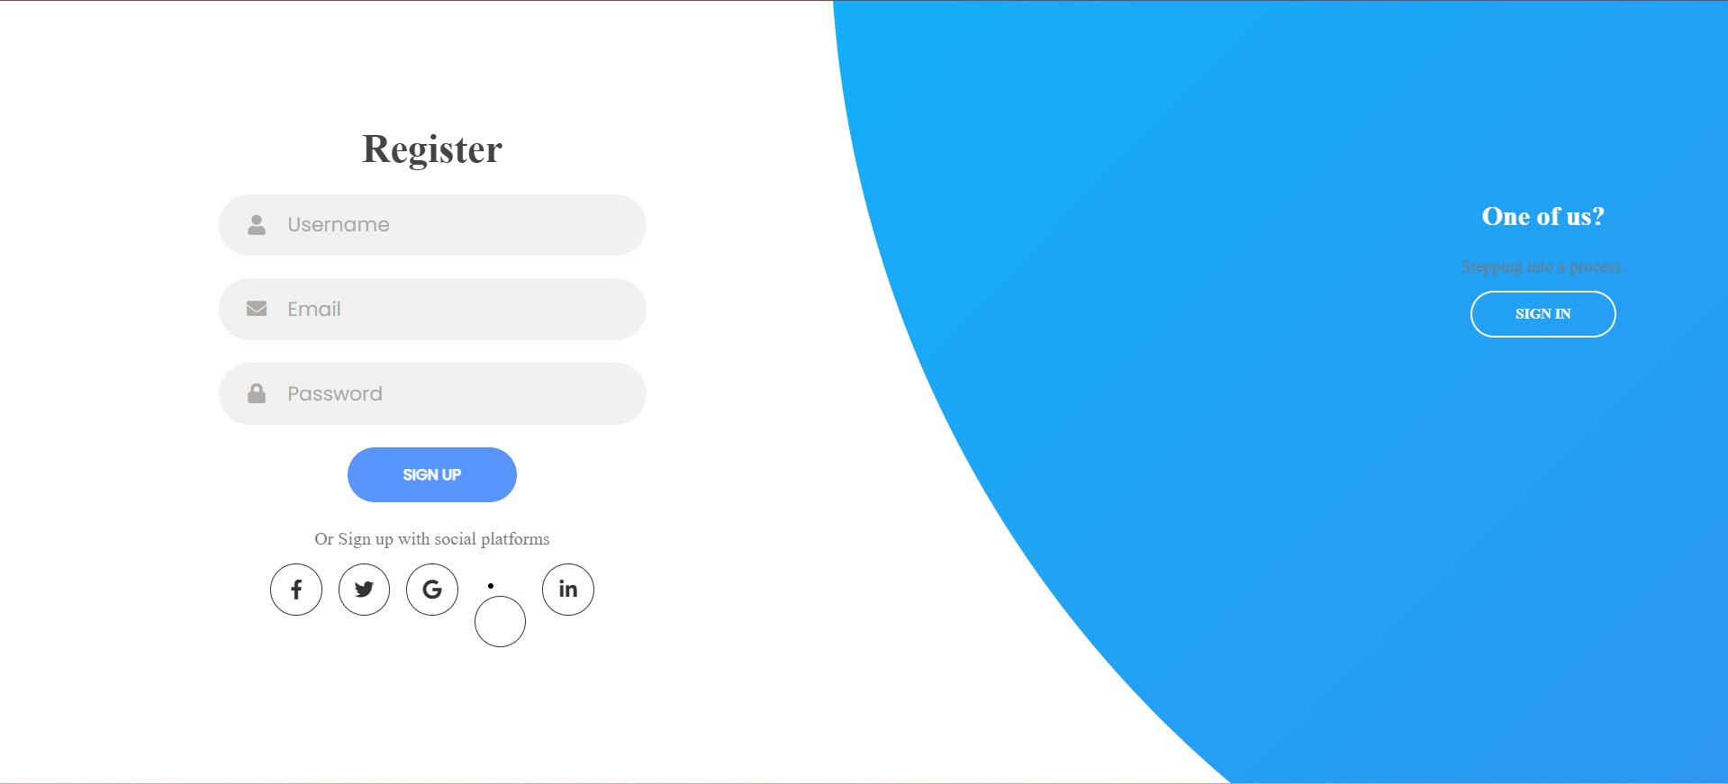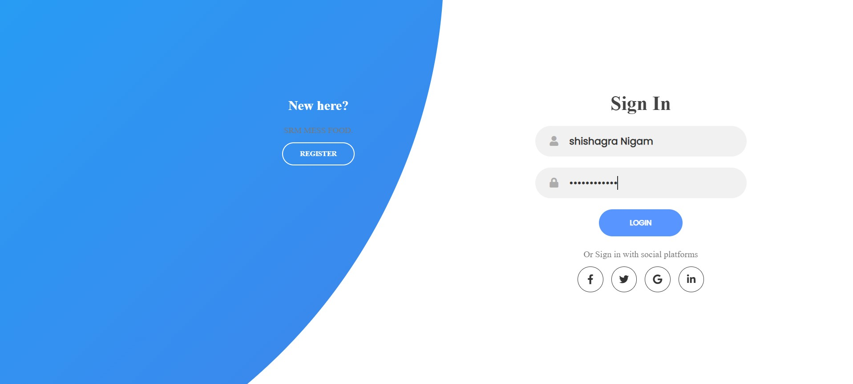

Github link for the login page: <https://github.com/Shishagra-Nigam19/srm-mess-food12>

**Mess website landing page (responsive)**

Navbar

1.Home

2.About

3.Category

4.Menu

5.Contact

A logo name **SRM FOOD** is present

A section is made where **About** details are there.

Next section takes us to the **category** of the food present in mess i.e

1.Vegetarian

2.Non - Vegetarian

3.Chinese

This section involves transition and hover effect in the view of css

A section **Food Menu** is present in which a individual can see what are the dishes that's usually available in mess.It consist of the image of the dish on left side and on right side it consist of items used in preparing it.

A **contact** form is been made which enables student to give their valuable feedback about it.It consist of name ,email and msg text area and a submit button.

Related pictures are kept all around the website

**Book and Order Your Food**

Done By  
Aryan Kumawat

**Overview**

The Food Ordering System is a web-based application designed to allow users to select and order food items from a menu. Users can add food items to their cart, view their cart contents, and proceed to checkout. The system also tracks the user's points, which are deducted when they add items to their cart. Users cannot add more food items once their points are exhausted.

**Features:**

1. Menu Display: The system displays a menu of available food items, along with their prices and descriptions. Users can browse through the menu to select their desired items.

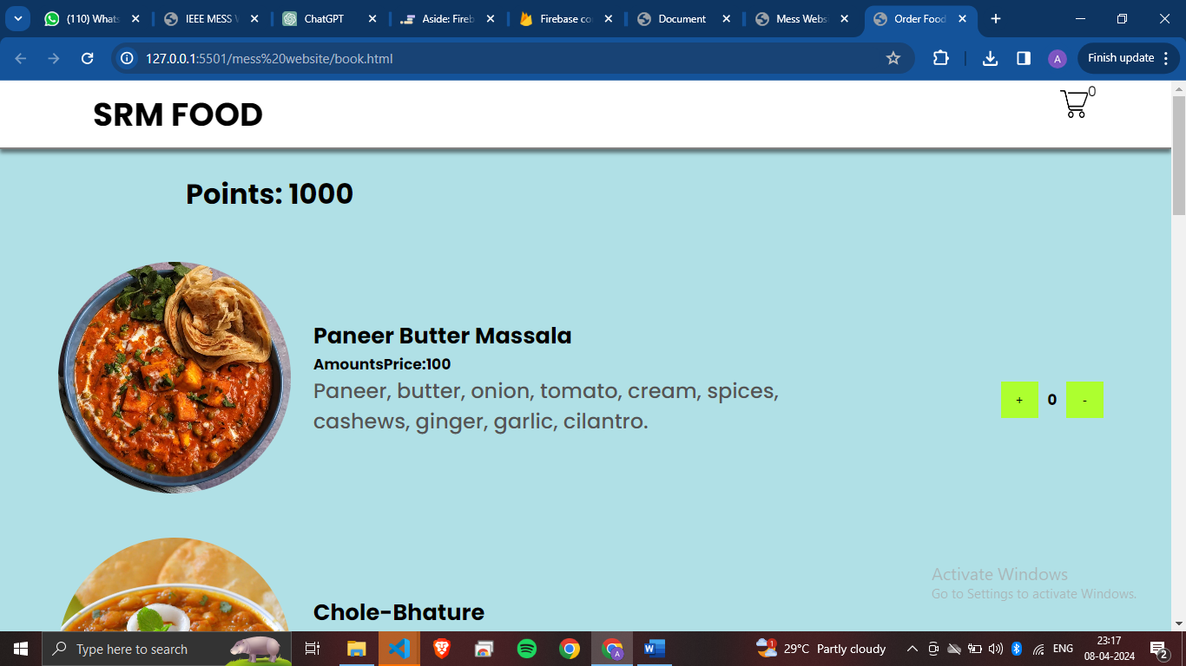

1. Add to Cart: Users can add food items to their cart by clicking the "Add to Cart" button next to each item. When an item is added to the cart, the user's points are deducted accordingly.

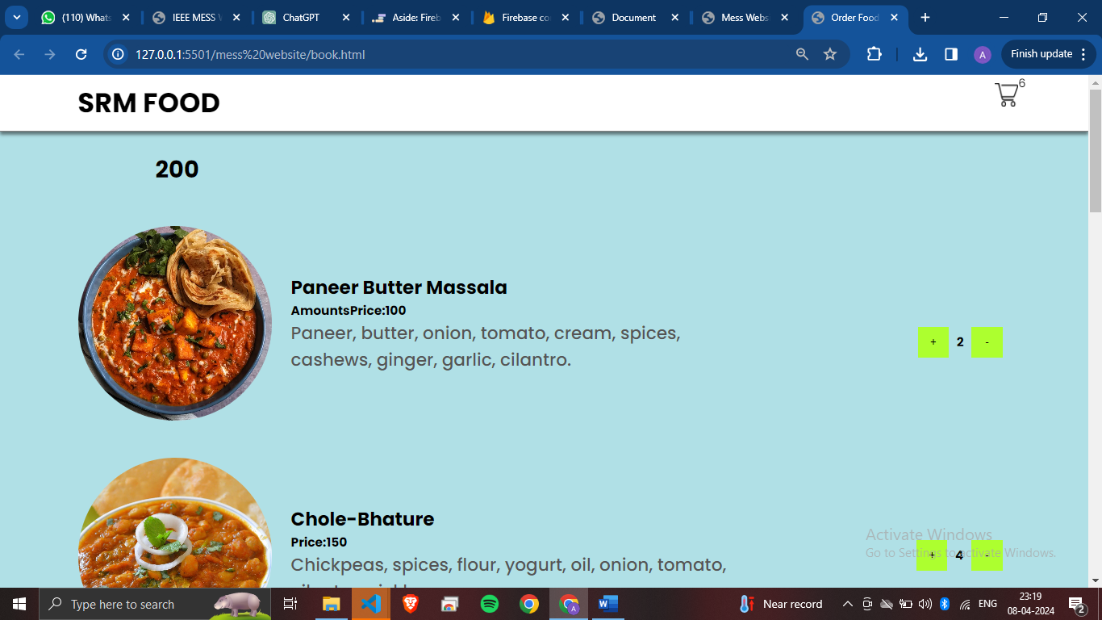

3. Cart Management: The system maintains a cart for each user, displaying the selected food items along with their quantities and total points deducted. Users can view their cart contents and remove items if desired. Further modifications is being implemented

1. Points Tracking: Users are allocated a certain number of points, which are deducted each time they add an item to their cart. The system prevents users from adding more items once their points are exhausted.

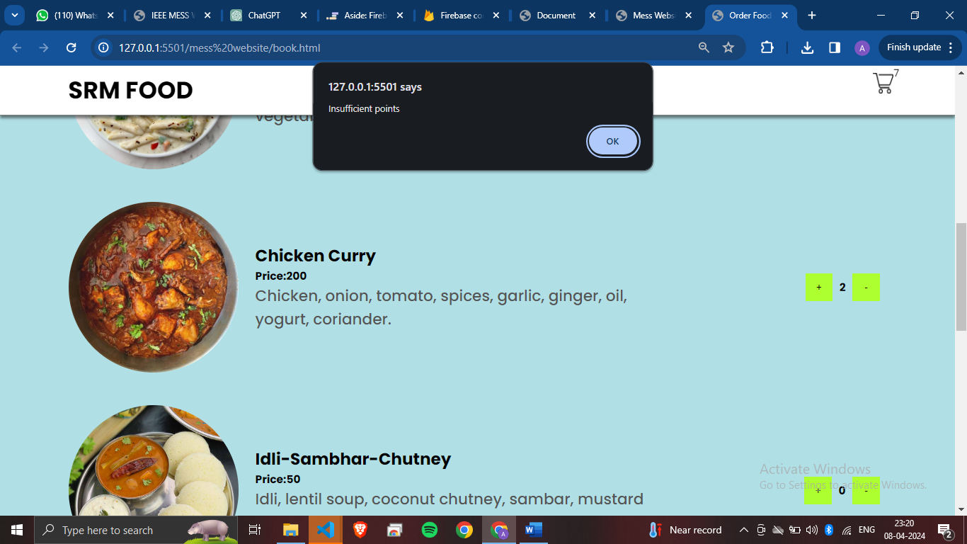

**Technical Implementation:**

- Frontend: The frontend of the Food Ordering System is implemented using HTML, CSS, and JavaScript. HTML is used to structure the web pages, CSS is used for styling, and JavaScript is used for dynamic behavior such as adding items to the cart and updating points.

Conclusion:

The Food Ordering System provides a convenient and efficient way for students to select and order food items from a menu. By incorporating features such as points tracking and cart management, the system ensures a seamless user experience while placing orders within the allocated points. With its user-friendly interface and robust functionality, the Food Ordering System meets the needs of both users and food providers, making it a valuable tool for online food ordering.